**Tribhuvan University Faculty of Humanities and Social Sciences (BCA)**

**Tribhuvan University**

Saraswati Multiple Campus



**MATLAB report**

Submitted by: Bikram Gyawali

Roll Number: ….. Submitted to: ………..

Semester : 1st Semester

Signature

**Introduction**

Allow me to introduce myself, for you are about to encounter a force to be reckoned with. I am the epitome of brilliance, a prodigy in the making, and a maestro of intellect. My journey through the realms of **knowledge** is nothing short of legendary, fueled by my insatiable thirst for greatness.

Behold, for I have mastered the art of **Matlab** with unparalleled finesse, honing my skills under none other than the illustrious **Prahlad Sir himself**. Yes, you heard it right! I, the one and only, have been tutored by the very best in the field, absorbing knowledge like a sponge and transforming it into sheer **computational prowess**.

But wait, the spectacle doesn't end there! Brace yourselves as I unveil my latest conquest: a seamless transition from the realm of software engineering to the prestigious domain of civil engineering. Oh, how effortlessly I navigate through the corridors of academia, leaving mere mortals in awe of my rapid ascent to greatness.

You see, my dear audience, I am not just another mortal bound by the shackles of mediocrity. No, I am a force of nature, a beacon of excellence illuminating the path to success for all who dare to follow. So bow down before me, for you stand in the presence of sheer brilliance, unmatched and unrivaled in every conceivable way!

**Introduction to MATLAB**

Matlab are akin to metronomes in the realm of mathematics. They serve to regulate and synchronize calculations, much like a metronome maintains tempo in music. With Matlab Beats, mathematicians can precisely time their computations, ensuring consistency and accuracy.

These digital tools emit regular pulses, akin to beats, providing a rhythm for mathematicians to follow as they engage in their numerical endeavors. By adjusting the tempo, or the rate of calculations, mathematicians can control the pace of their work, just as musicians do with music.

Whether tackling complex algorithms or executing iterative processes, Matlab facilitate a steady complex understanding for mathematicians to work with, enhancing efficiency and productivity in numerical analysis and problem-solving tasks.

**Matrix Introduction**

* Matrix is 2 dimensional array
* Multiple dimension vector to say more
* Following is example

1 5 6 7 6 6

5 4 6 4 6 6

4 2 7 6

One is 4x4 and other is 2x2

**Row Matrix:** Matrix having only one row and single

column is called row matrix Example:

**Column Matrix:** Matrix having one column and single rows is called column matrix Example:

**1**

**6**

1. **2**

**Lab-1 (Matrix Arithmetics)**

**Addition of Matrices:** Two matrices only with same order can be added together.

**Subtraction of Matrices:** Two matrices only with same order can be subtracted together

**Matrix Multiplication:** Matrix multiplication is only possible if column of first matrix and row of second matrix are equal and performed as row of first matrix times column of second matrix.

Solution: codes in MATLAB:

A= 1 3 5

1. 3 1

1 5 3

B= 2 4 6

4 2 6

1. 4 2

>>A*B

Ans= 41 10 33

22 63 44

71 26 33

**Lab-2 (Determinants of matrices)**

The determinant is condensed value of matrix.

Singlehandedly represents behavior matrix

Solution: codes in MATLAB

A= 9 3 9

# 9 7 9

# 4 6 4

>>det(A) Ans= -7

Qn.4 find determinant of matrix

Solution: in MATLAB

A =

7 9 9

9 9 7

9 6 7

>> det(A)

ans =

34.0000

**Lab-3(Inverse of matrix)**

Inverse of Matrix: Inverse of matrix is matrix which gives identity matrix when multiplied with it's original state to find inverse of matrix we need to know that matrix should be

singular(determinant should not be equal to zero) and adjoint of matrix is also needed to find the inverse of matrix A is denoted by A-1 mathematically A-1 =adj(A)/|A|

Qn.5 find inverse of matrix

Solution: in MATLAB

A =

7 9 5

4 6 7

2 3>> inv(A) 8

ans =

1.0000 -2.1111 1.2222

-0.6667 1.7037 -1.0741

0.0000 -0.1111 0.2222

Qn 6 Find the inverse of matrix

Solution: in MATLAB

A =

* + 1. 4 6
    2. 3 9

5 7 8

>> inv(A)

ans =

-0.5493 0.1408 0.2535

0.4085 -0.3099 0.0423

-0.0141 0.1831 -0.0704

**Lab-4(Adjugate of matrix)**

**Adjugate of Matrix:** The matrix obtained by interchanging the columns and rows of co-factor of matrix is called adjugate of matrix.

Qn.7 find adjoint of A using MATLAB Solution: in MATLAB



A=

>>det(A)*inverse(A)

Ans=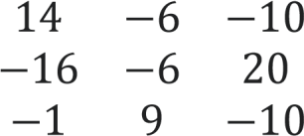

Qn.8 If 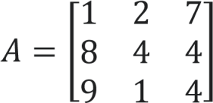 find adjoint of A using MATLAB

Solution: in MATLAB

>> A=[1,2,7;8,4,4;9,1,4]

A =

1 2 7

1. 4 4
2. 1 4

>> det(A)*inv(A)

ans =

12.0000 -1.0000 -20.0000

4.0000 -59.0000 52.0000

-28.0000 17.0000 -12.0000

**Lab-5(Rank of Matrices)**

The rank of a matrix is the maximum number of its linearly independent column vectors (or row vectors). It is blatant that the rank of a matrix cannot exceed the number of its rows or columns.

# therefore determinant is not equal to zero so as a result this given matrix has rank of it’s order that is 3

Qn. 9 If find the rank of the matrix using

MATLAB.

Solution: In MATLAB

A=

>>

rank(A)

Ans= 4

x+2y=13

4

Solution: in MATLAB

>>

A=[1 3; 4 2];

>>

b=[12;13];

X =

1.5000

3.5000

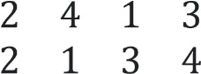

**Lab-6(Solve by matrix method)**

Qn.10 Find the value of x and y using MATLAB x+3y=12

Qn.11 Find value of x,y,z from given equation using

MATLAB x+y+z=9, 2x+5y+7z=52 & 2x+y-z=0 Solution: >> A=[1 1 1; 2 5 7; 2 1 -1];

>> b=[9; 52; 0];

X =

1

3

5

**Lab-7 (Equation operations)**

An equation is a formula that expresses the equality of two expressions, by connecting them with the equals sign "=" and when we evaluate it further 0=0 may be the result

Example : 

Qn.12 solve 4x2+14x+10=0 manually and by using matlab

In MATLAB

>> syms x

>> solve(4*x^2+14*x+10==0,x)

ans =

-7/2

-1

Qn.13 solve x2+5x+6=0 manually and by using matlab Solution:

=>x2+5x+6=0

=>x2+2x+3x+6=0

=>x(x+2)+3(x+2)=0

=>(x+3)(x+2)=0

Either x+3=0=>x=-3

Or x+2=0=>x=-2

In MATLAB

>> syms x

>> solve(x^2+5*x+6==0,x)

ans =

-3

-2

Qn.14 solve x-2-5x-6=0 manually and by using matlab Solution:

=> x-2-5x-1-6=0

Solving and getting

x-1=-1 x=- x-1=6

1 x=1/6

In MATLAB

>> syms x

>> solve(x^-2-5*x^-1-6==0,x)

ans =

-1

1/6

Qn.15 Solve the equation x3-2x2-5x+6=0 manually and using MATLAB

Solution:

f(x)= x3-2x2-5x+6=0

Values that might make equation possible are ±1, ±2, ±3 and ±6 f(1)=(1)3-2(1)2-5(1)+6= 1-2-5+6= 0 one value is 1 which is (x-1)

1 1 -2 -5 6

1 -1 -6

1 -1 -6 0

Equation obtained= x2-x-6

=>x2-3x+2x-6=0

=>x(x-3)+2(x-3)=0

=>(x-3)(x+2)(x-1)=0 [above equation: (x-1)]

Either x-3=0=>x=3

Or x+2=0=>x=-2

Or x-1=0=>x=1

**In MATLAB**

>>syms x

>> solve(x^3-2*x^2-5*x+6==0,x)

ans =

-2

1

3

**Lab-8(Vectors and plotting in graphs)**

**Vector:** Vector is one direction ray of element that gives one dimension row or column unlike matrix this is different this gives one direction magnitude and direction

**Some types of vector:**

1. **Unit vectors:** Vectors that have magnitude equals to 1 are called unit vectors, denoted by a^. It is also called the multiplicative identity of vectors. The length of unit vectors is 1. It is generally used to denote the direction of a vector.

1. **Parallel vectors:** Two or more vectors are said to be parallel vectors if they have the same direction but not necessarily the same magnitude. Vectors are said to be parallel if their cross product is 0(a×b=0).
2. **Zero or null vectors:** The vector having magnitude 0 is called zero vector. Ex: 

**Qn.16 find Magnitude of 4i+2j-k**

Solution: in MATLAB

>> a1=4;

>> a2=2;

>> a3=-1;

>> Magnitude=sqrt(a1^2+a2^2+a3^2)

Magnitude =

4.5826

**Qn.17 find a.(bxc) and ax(bxc) using MATLAB if**



**=4i+7j+10k and**  **40j+k and** **4k**

**Solution**

**I. For a.(bxc) using MATLAB** >> a=[4 7 10]

1. =

4 7 10 >> b=[9 -40 1]

1. =

9 -40 1 >> c=[1 -1 -4]

1. =

1 -1 -4

>> dot(a, cross(b,c))

|  |  |
| --- | --- |
| ans =    1213    **ii. For ax(bxc) In MATLAB**  >> a=[4 7 10]     1. =     4 7 10    >> b=[9 -40 1]     1. =     9 -40 1    >> c=[1 -1 -4]     1. =     1 -1 -4      **Qn.18 find a.(bxc) using MATLAB if**  **11jk and**  **4k** | **=1i+4k and** **=i-**  17 |

**Solution using MATLAB**

>> a=[1 0 4]

1. =

1 0 4

>> b=[2, 12, 99]

1. =

2 12 99

>> c=[1 -1 -4]

1. =

1 -1 -4

>> dot(a, cross(b,c))

ans =

-153 1486 -979

**Lab-9(Plotting in graphs)**

**Qn.19: plot the following linear graph y=2x+10 within the range of [-8,10] Solution:**

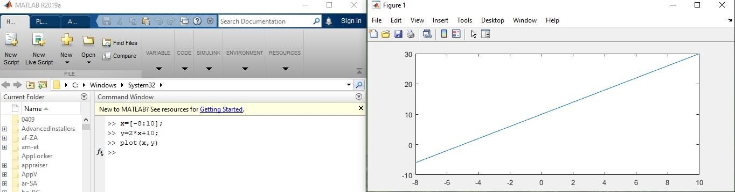

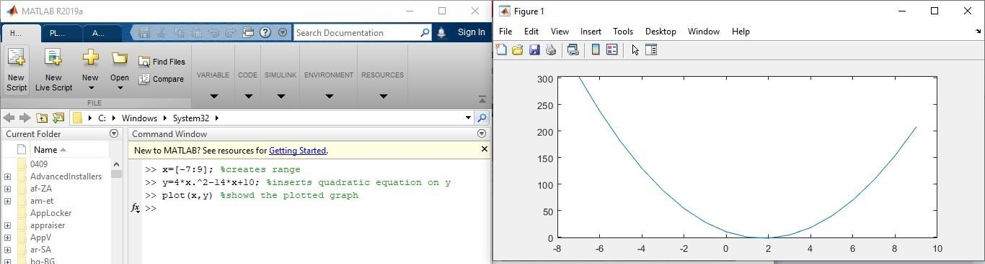

**Qn. 20: plot the following polynomial graph and show parabola**

**Qn. 21**

**:**

**gi**

**ve sinegraph**

**The End**

